Supplemental Information

Particle-modified polymeric cladding on glass optical fibers enhances radial light scattering
Mariana Lanzarini-Lopes,^{1,3} Sergi Garcia-Segura,¹ Kiril Hristovski,^{1, 2} Mike Messerly,³ A.J. Simon,³ Paul Westerhoff^{1,*}
¹Nanosystems Engineering Research Center for Nanotechnology-Enabled Water Treatment, School of Sustainable Engineering and the Built Environment, Arizona State University, Tempe, AZ 85287-5306, USA
² The Polytechnic School, Ira A. Fulton Schools of Engineering, Arizona State University, Mesa, AZ 85212, USA
³ Lawrence Livermore National Laboratory, Livermore, CA 94550, USA
*Corresponding author email: p.westerhoff@asu.edu; phone: 480-965-2885

S.I. Fig. 1. Effect of material type on the fractional scattered flux at 1 m position $(I_{s,1m})$for deuterium lamp source input$(I_{0})$ emitting light with wavelengths between 350 and 570 nm. Fractional scattered flux of 1.0 % wt. barium sulfate (Sigma-Aldrich: 202762) and 1.0 % wt. of a white crystalline polytetrafluorethylene powder (Zonyl™ MP1200, DuPont) were compared with the 1.0 % wt. silica microspheres and unmodified optical fiber. Results here motivated use of silica spheres for the remainder of the study higher absorbance in the UV range and is similar for both polymers.
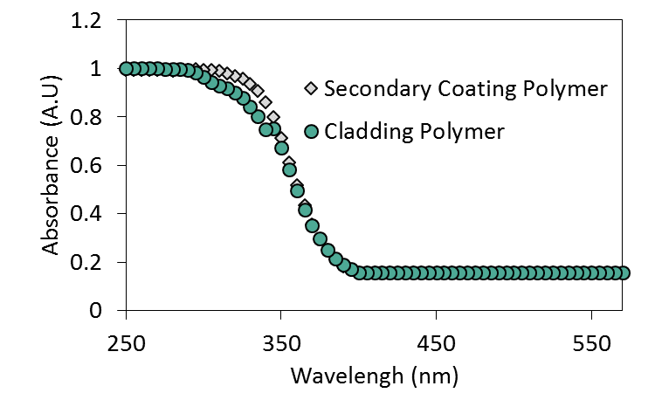
S.I. Fig. 2. Absorption spectra of cladding polymer (DeSolite DF-0016 (cladding material) and the secondary coating polymer (DeSolite DS-2015) for wavelengths from 350 nm to 570 nm. Absorption spectra was obtained with a UV-VIS spectrophotometer DR 500 at 20 and 43 µm thickness (measured by Bruker XT profilometer) for the cladding and secondary coating polymer, respectively. To compare absorbance between polymers, the value was adjusted for 30 µm thickness using Beer-Lambert law as explained in this manuscript. Results illustrate significantly higher absorbance in the UV range and is similar for both polymers.
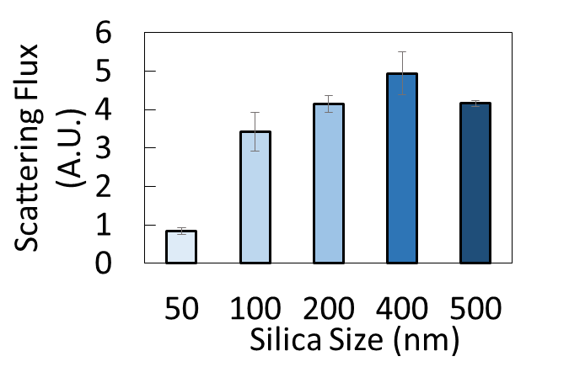
S.I. Fig. 3. Effect of particle size on 265 nm wavelength localized scattering flux. Silica sphere (1.6 µg/mm²) was attached to bare core optical fiber by dip coating and the flux was measured by spectrophotoradiometer. Diameters of 200 nm or above achieved similar scattering (p > 0.10), with slightly more scattering than 100 nm diameter particles (p = 0.023), and more than 5x higher scattering than 50 nm spheres. To obtain effective side emission from optical fibers, spheres > 200 nm should be selected. Values illustrated are averaged triplicates with one standard deviation above and below.

